Boxwood Garden Order Form

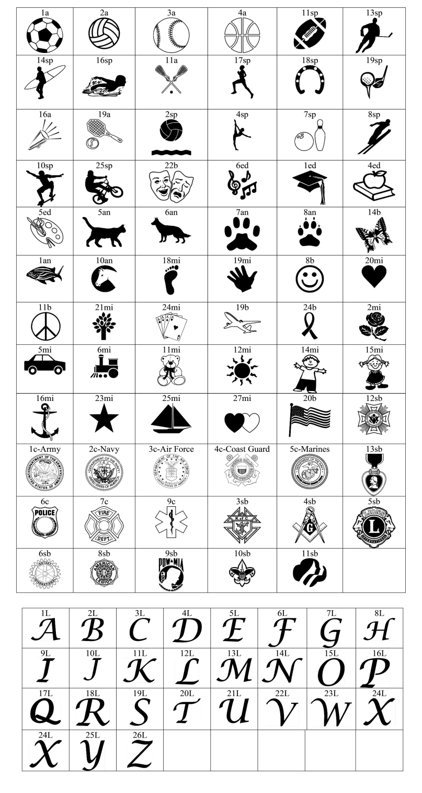

YOUR INFORMATION

Your Name: _____________________________________

Phone: _________________________________________

Email: __________________________________________

Address: ________________________________________

_______________________________________________

City: ___________________________________________

State__________ Zip_____________________________

RECIPIENT’S INFORMATION

Their Name: ____________________________________

Phone: ________________________________________

Email: _________________________________________

Address:_______________________________________

_______________________________________________

City:___________________________________________

State__________ Zip_____________________________

WHO WOULD YOU LIKE THE CERTIFICATE SENT TO?

___You ___ Recipient ***(Please choose one)***

WHICH STYLE WOULD YOU LIKE IT PRINTED IN?

*___* Floral Motif ___ Blue Patterned **(*Please choose one)***

ENGRAVING INFO – WITHOUT ART

Your 4 inch by 8 inch brick can have up to 3 lines and 20

characters per line (this includes spaces and punctuation).

ENGRAVING INFO – WITH ART   
*(the shaded area would be the art)*

Your 4 inch by 8 inch brick can have up to 3 lines and 12

characters per line (this includes spaces and punctuation).

Please make sure your engraving information is spelled

correctly. **Please print clearly.**

Brick: 4 inch by 8 inch

***(Do not use shaded area when including clipart)***

**

___ 4” x 8” text Only @$100 each ______________

___ 4” x 8” with Art @$125 each _______________

Total enclosed_____________________________

Please make checks payable to Southold Historical Society and mail this form with your check to:

**Southold Historical Society**

**54325 Main Road, PO Box 1**

**Southold, NY 11971**

You may complete your transaction online at: [www.brickmarkersusa.com/donors/shs.html](http://www.brickmarkersusa.com/donors/shs.html)

If you have any questions, please contact Deanna Walker at sohissoc@optonline.net or 631.765.5500 ext. 2 **(*Contributions are tax-deductible.)***

Art Number:

Art Number: